Query the two cities in **STATION** with the shortest and longest CITY names, as well as their respective lengths (i.e.: number of characters in the name). If there is more than one smallest or largest city, choose the one that comes first when ordered alphabetically.

**Input Format**

The **STATION** table is described as follows:

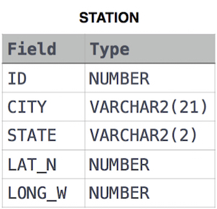

where LAT_N is the northern latitude and LONG_W is the western longitude.

**Sample Input**

Let's say that CITY only has four entries: DEF, ABC, PQRS and WXY

Solution:

select city, length(city) L

from (select city, length(city) L from station order by L, city) where rownum = 1

union

select city, length(city) L from (select city, length(city) L from station order by L desc, city) where rownum = 1;